**Include answers to the following:**

There are 32 London Boroughs. We looked at price increase and ratio in these areas.

In general, London boroughs had the greatest increase in housing prices from 1998 to 2018.

1. The 'Hackney' Borough is the most expensive, followed by 'Waltham Forest', 'Southwark',

'Lewisham', 'Westminster' which made top 5. The average housing price ratios are between 6.198(the highest is Hackney) to 4.76(in Greenwich – on the 15th place) from 1998 to 2018.

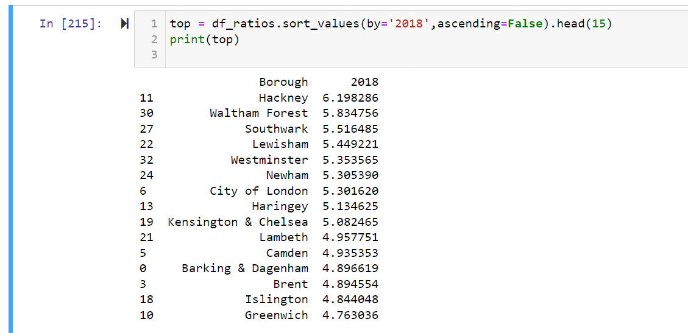

2. The average price for the "Camden"(the borough we chose for our analysis) an estimated

increase was around 5 times, and the price increase ratio for two consecutive decades is 4.93, which is the tenth highest.

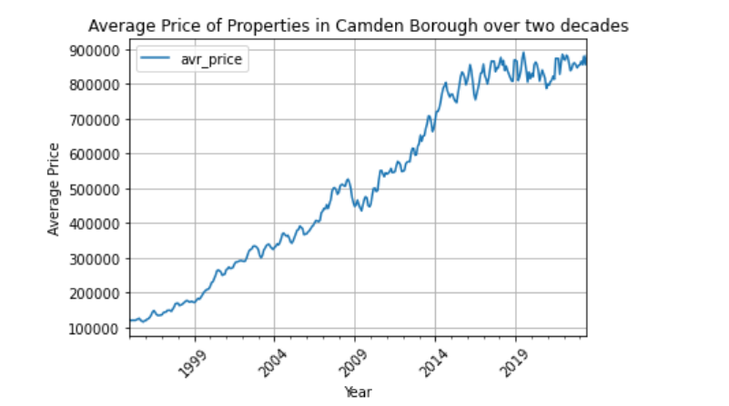

Overall, prices of boroughs increased significantly over the decade of 1998 - 2008.

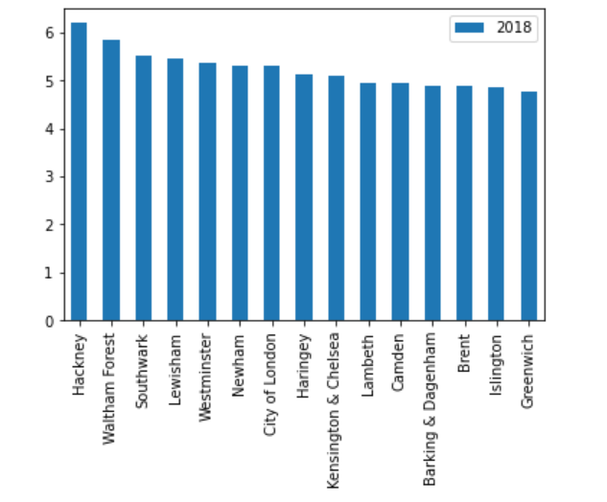

The analysis showed valuable information about the price variations of the London boroughs.

Also we saw that the housing prices have a positive trend to increase in the future, making it a good investment opportunity for potential buyers.

The main challenge was that to sort the knowledge I have grasped over the study and use it where it was necessary. Functions and syntax writing was a little hurdle in a sense of, I was confused which one to use where and how to write with correct syntaxes.

**Is there anything you’d like to investigate deeper**?

I assume that the data was analysed enough to draw a conclusion.

There are only 32 London Boroughs